Go to making of America and pick a magazine, such as U.S. Democratic Review
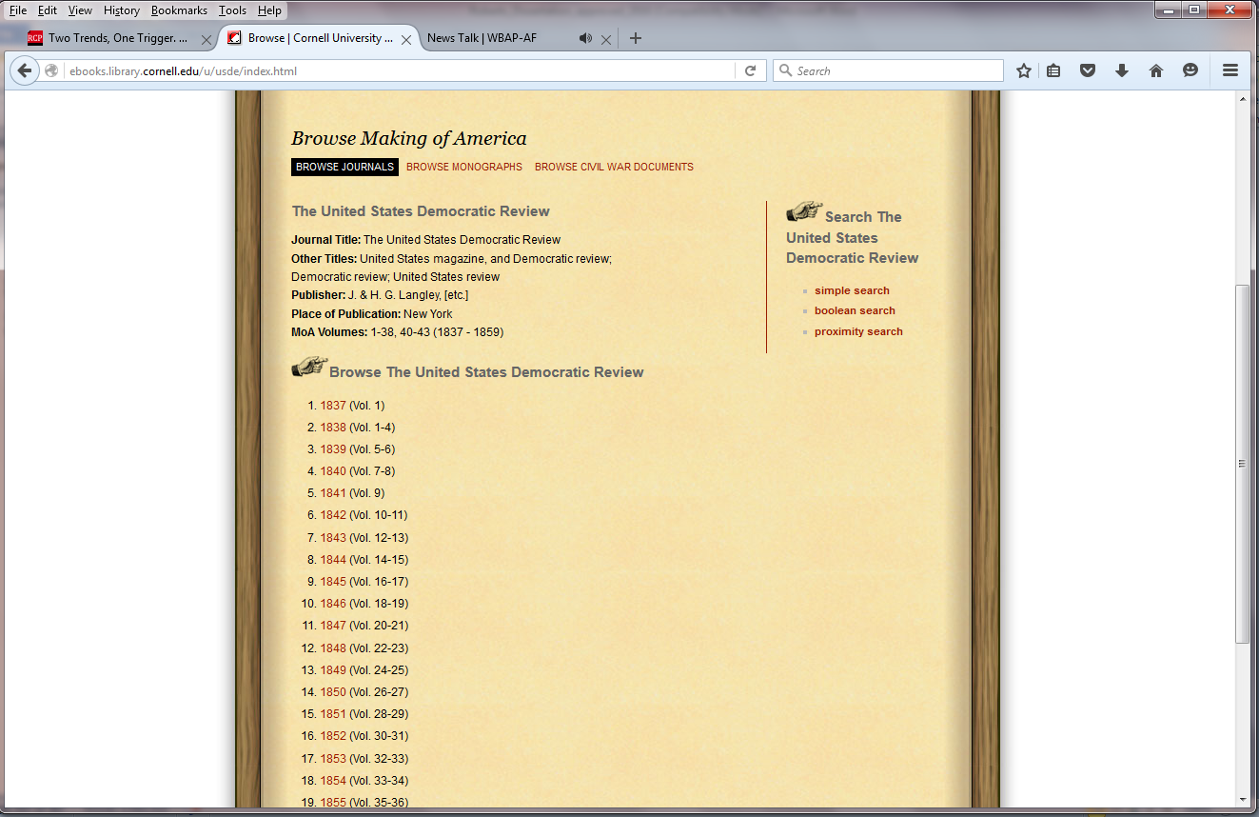
Pick the year—such as 1838
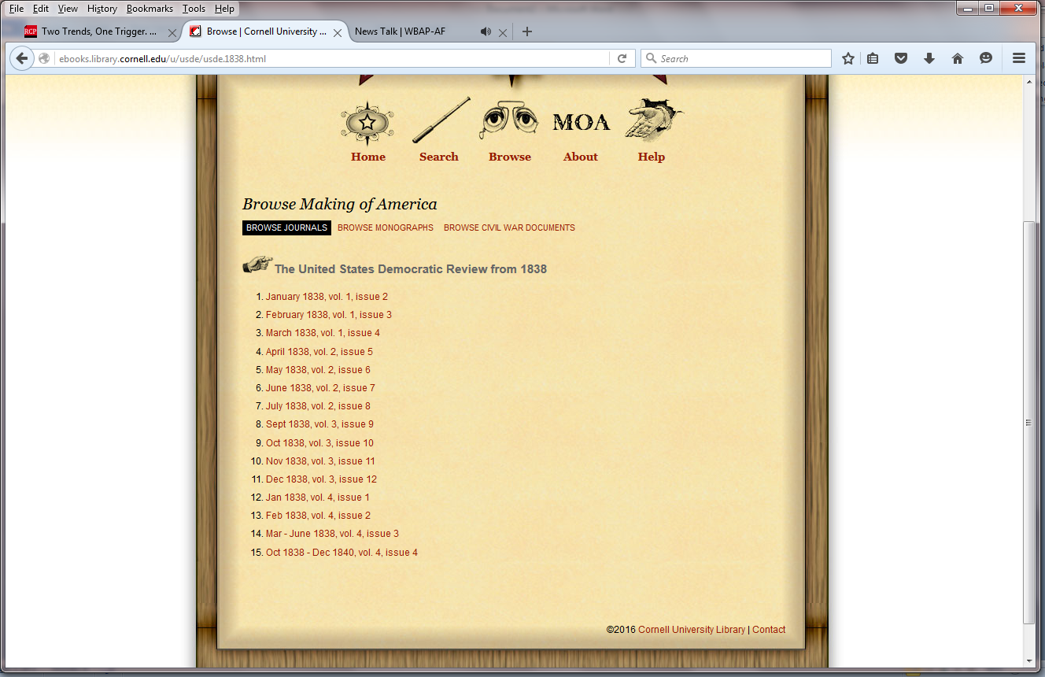
Pick the month
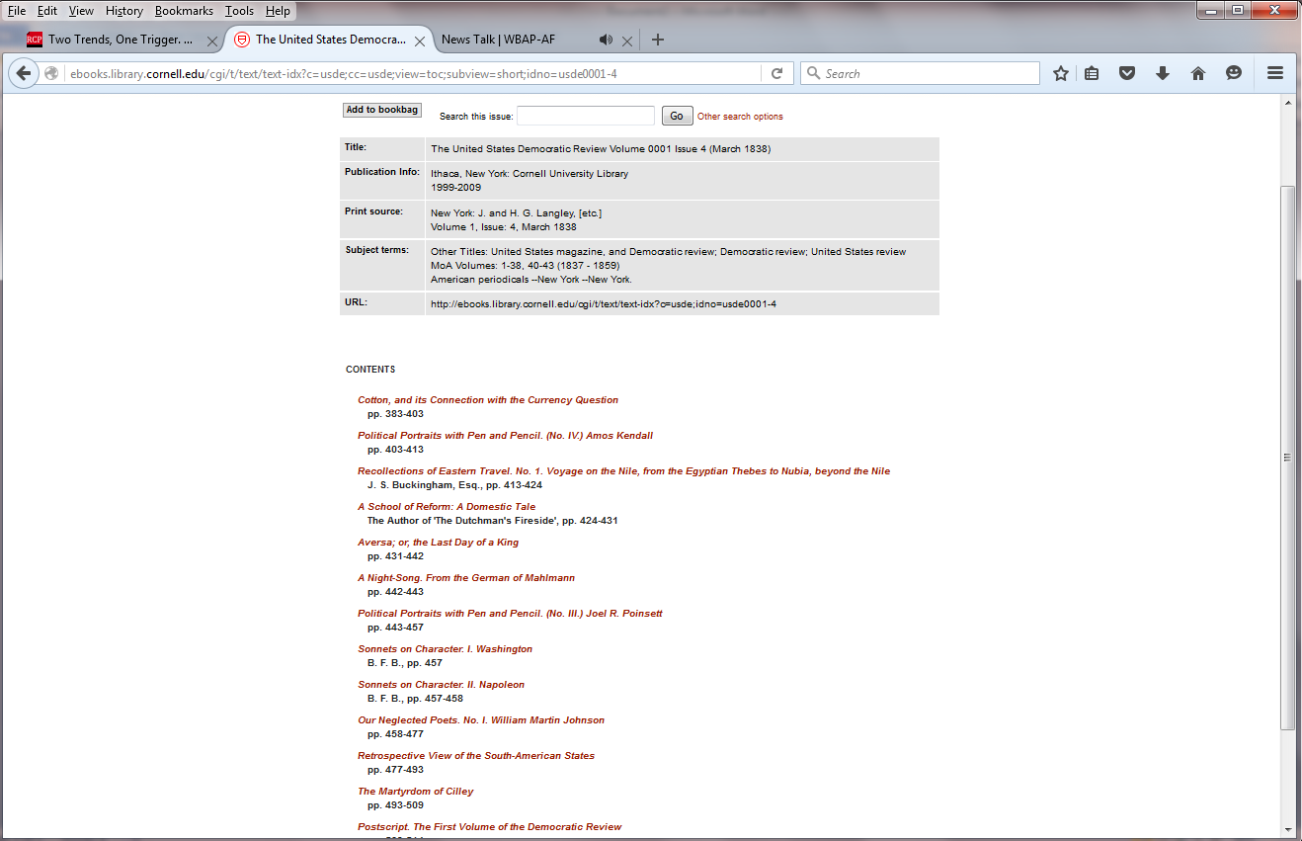
Here is the list of all the stories in that issue. For the bibliography, I need you to take the bibliographic information from this page, list the first 5 articles in the issue, then tell me why you selected that magazine/issue.
Should all fit in one paragraph typed up for turn in.
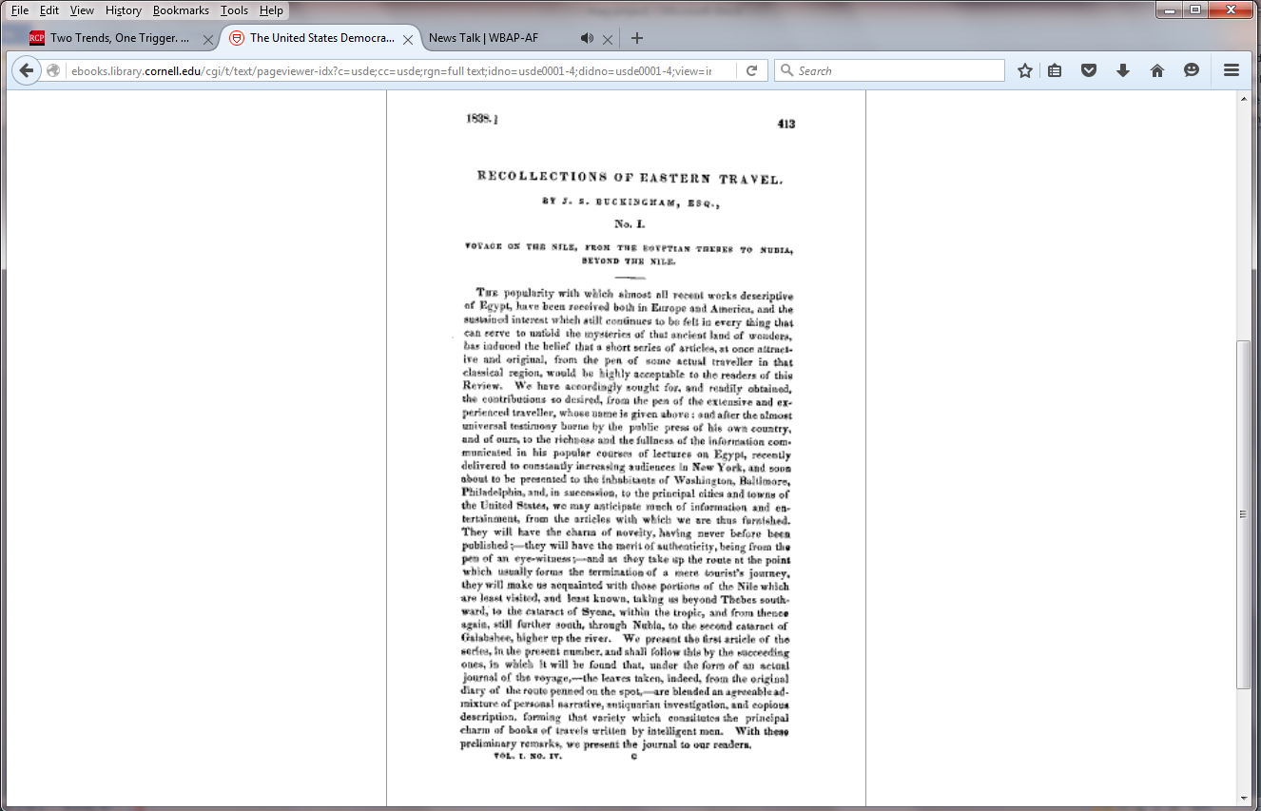

Making of American at Cornell
Making of American at Cornell: http://ebooks.library.cornell.edu/m/moa/browse.html
- The American Whig Review (1845 - 1852)
- The Atlantic Monthly (1857 - 1901)
- Harper's New Monthly Magazine (1850 - 1899)
- The International Monthly Magazine (1850 - 1852)
- The Living Age (1844 - 1900)
- The New-England Magazine (1831 - 1835)
- New Englander (1843 - 1892)
- The North American Review (1815 - 1900)
- Putnam's Monthly (1853 - 1870)
- Scientific American (1846 - 1869)
- The United States Democratic Review (1837 - 1859)

Making of America at Michigan
Making of America at University of Michigan: http://quod.lib.umich.edu/m/moajrnl/browse.journals/ http://quod.lib.umich.edu/m/moajrnl/browse.journals/
DeBow's 1846-1869 + 1952 index (3 series)
Ladies Repository 1841-1876 (3 series)
Southern Quarterly Review 1842-1857 (3 series)
Princeton Review 1831-1882 (3 series)
Southern Literary Messenger 1835-1864
Southern Quarterly Review 1842-1857 (3 series)

